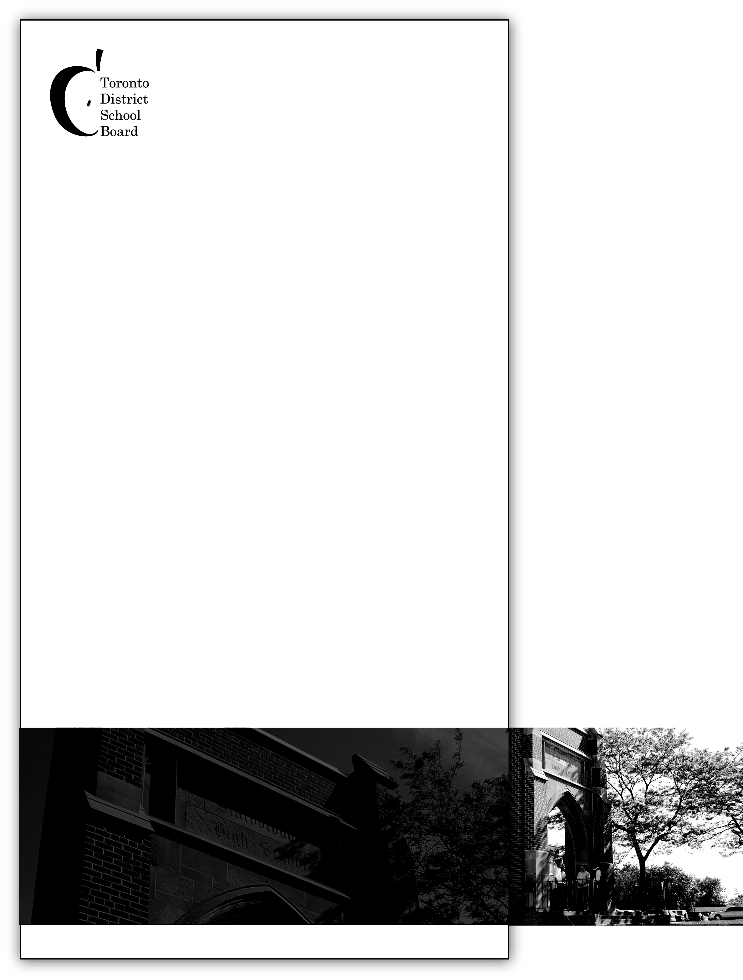
St. Margaret’s Public School

235 Galloway Road Principal: Ms. R. Tohana
Toronto, ON Vice-Principal: Mr. R. Robinson
M1E 1X5 Office Administrator: Ms. I. Nour
416.396.6550 Superintendent: Ms. S. Robinson Petrazzini
Trustee, Ward 19: Mr. Zakir Patel
Website - http://schoolweb.tdsb.on.ca/stmargarets/Home.aspx
Twitter - @tdsb_SMPS

A Message from Your School Administration Team
May looks to be a very busy month as we celebrate Asian and Jewish Heritage Months at our school. It is also Children’s Mental Health Week during the week of May 6th. Our Gr. 4-8 students have been practising for our Track and Field Meet at Birchmount Stadium on May 10th. Our Gr. 3 and 6 students continue to work hard preparing for the EQAO assessments that will be starting on May 27th. We will be having our Parent Information session on Monday, May 6th for parents/caregivers of students in Gr. 3 and 6. If you would like to learn more about the assessments, please visit www.eqao.com.

We would like to extend a warm welcome to Ms. Clarke, who is filling in for Mr. Robinson while he is off recovering from knee surgery. We wish him a speedy recovery and thank Ms. Clarke for her support.

There are also a number of parent/caregiver workshops that are being offered this month, including a special presentation on “Empowering Parents” by Kim Tavares on May 7th. Please see the “Upcoming Dates” section of our newsletter and mark these events in your calendars. We hope to see more parents participating in our informative sessions.

We are committed to communicating regularly with our school community through monthly newsletters, our school Twitter account (@tdsb_SMPS), and our school website: http://schoolweb.tdsb.on.ca/stmargarets. Ms. Kim, our teacher-librarian and ESL teacher, has designed the website with parents and our community in mind, keeping everyone up-to-date about what is happening in our school and community. You can get the latest on our school’s athletics, updates from student clubs, newsletters for download, information on free events for parents and students, and much more.

In Partnership,
Ms. R. Tohana Mr. R. Robinson

May 2019
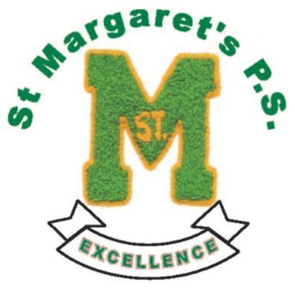

Upcoming Dates

May 2 | Financial Literacy Workshop for Parents, 9:00am in Library
May 3 | Mr. Hirji & Gr. 7/8 Boys to Stand Up Conference
May 6-10 | Children’s Mental Health Week
May 6-10 | WE Club’s Pop-up Shop
May 6 | EQAO Parent Information Night, 5:00-6:00pm
May 7 | “Empowering Parents” Presentation at 3:30pm
May 8 | Ms. Patel’s class to Young People’s Theatre
May 9 | Mr. Cragg’s class to “Unity in the Community”
May 9 | Financial Literacy Workshop for Parents, 9:00am in Library
May 10 | Gr. 4-8 Track & Field Meet at Birchmount
May 10 | Ms. Richards & Ms. Pearce’s Classes to Ripley’s Aquarium
May 14 | Ms. Patel’s class tree planting in Rouge Park
May 15 | Ms. Kim & Library Leaders to Forest of Reading Celebration
May 16 | WE Walk for Water



Upcoming Dates
(continued)

May 16 | Financial Literacy Workshop for Parents, 9:00am in Library
May 17 | Asian Heritage Month Assembly, 12:40pm
May 20 | Victoria Day Holiday (no school)
May 21 | Financial Literacy Workshop for Parents, 9:00am in Library
May 22 | Welcome to Kindergarten, 5:30-6:30pm
May 23 | Parent Council Meeting, 9:00am
May 23 | School Pizza Lunch
May 24 | Ms. D’Cruz, Ms. Asirvatham & Ms. Felix’s classes to Legoland
May 27-31 | Gr. 3 & 6 EQAO
May 30 | Kids, Cops & Computers Inspiration Games
May 30 | Financial Literacy Workshop for Parents, 9:00am in Library
May 31 | Character Education Assembly, 10:30am

May is Asian Heritage Month!
Asian Heritage Month is recognized during the month of May at the Toronto District School Board. Our theme this year is, “Our stories. Our voices. Our journey.”
Asia is a land of great political, economic, social, ethnic, cultural and religious diversity; this diversity creates challenges when we attempt to define Asia in geographic and political terms. More than 40% of TDSB students identify as Asian.

During May, there will be many opportunities to celebrate the achievements and contributions of Asian Canadians and to recognize the narratives and wisdom of various Asian cultures. We will be having our Asian Heritage Month Assembly on Friday, May 17th at 12:40 p.m. We hope you can join us!

WE Walk for Water

The Me-to-WE club is passionate about helping people in need, locally and globally. Locally, we supported East Scarborough Storefront by donating $160 from our Fall Pop-Up Thrift Shop fundraiser. Globally, we supported children across the globe who don’t have the rights to speak up for themselves through our WE Are Silent campaign and raised $350 during our Silent Auction. Starting May 6, we are kicking off our WE Walk for Water campaign with a 5-day Pop-Up WE Shop during recesses, where students can purchase customized bracelets, baked goods, and samosas (samosa sales on Thursday, May 9 only). Last year, we raised $80. Our goal this year is to raise $150 to donate to WE Charities.

WE Charities’ global campaign of WE Walk for Water brings awareness about the women and girls in developing countries, such as Kenya, who walk an average of 5 km and between 5 hours to 20 hours each day to collect water for their families, water that is not even clean. As a result, many of their children die from avoidable waterborne diseases and girls cannot go to school because their entire day is spent walking for water.

Clean water is the fastest way to help a community break the cycle of poverty. When communities have access to clean water, girls can attend school, parents can run sustainable farms, and families can lead healthier lives.

With money raised from WE Walk for Water, the WE Charities are able to go into those villages to build a water system right in their communities. Every $25 raised gives 1 person water for life.

On May 16th, the Junior and Intermediate students will walk 5 km to a water source and some of them will carry water back to school in order to raise awareness on the impact that walking for water has on daily activities of children.

Letters will be sent home with more information about the WE Shop and WE Walk for Water event. We thank you in advance for your support in this global issue.

Submitted by the ME to We Club and Ms. Kim


School Updates



Pedestrian Safety - Safety Tips for Parents
Children under nine should be accompanied by adults or older children when crossing the street. At this age, their judgment and perceptual skills are still immature, yet they often eagerly try to cross streets on their own in order to demonstrate some independence. Teach your children the rules of the road - start when they're young. Think of it as gradually training your children about safety until all the connections are in place. By the time your child reaches age nine and can act independently, the road safety rules will be second nature.
- Teach children how to cross the street safely. Teach them to stop (before stepping onto the road), look left, right and left again, and listen for traffic before stepping out into the street. Teach children to wait until the street is clear and to keep looking until they have crossed the street. They should also look the driver in the eye before crossing.
- Teach children to recognize pedestrian crossing signals but not rely on them. Before crossing, children should also be sure the traffic has stopped. Remind them to continue across if the light changes to "Don't Walk" while they are in the crosswalk.
- Teach children to be extra alert when crossing at a corner with no traffic lights.
- Teach your children to stop at driveways, alleys and areas without curbs and to never run out onto the street.
- Teach children about the dangers of crossing the street between parked cars or when not at a corner. Children should cross only at corners and pedestrian crosswalks, not diagonally or between parked cars.
- Teach children to respect the role of the crossing guard and to understand his/her signals.
- Teach children that wherever possible, they should walk on the sidewalk. In areas without sidewalks, teach children to walk as far away from the road as possible, facing approaching traffic (when there is no choice but to walk on the road).
- Teach children that playing games at railway crossings or around trains can be deadly. Teach children that the only way to cross railway tracks is to use designated railway crossings.
Follow the same rules that you want your child to follow. You may want to cut across the street in the middle of the block, but you want your child to learn to cross at the intersection. Be a good role model.
Reprinted with the permission of Safe Kids Canada. Visit www.safekidscanada.ca for more safety tips on keeping children safe.

May’s Character Trait is
Integrity

“Real integrity is doing the right thing, knowing that nobody’s going to know whether you did it or not.”

~ Oprah Winfrey

Office Reminders
Please remember to call School Messenger at 1-833-250-2290 to report student absences. This number is available at any time of day.
Also, don’t forget to register for School Cash Online at https://tdsb.schoolcashonline.com/

St. Margaret’s Public School
235 Galloway Road
Toronto, Ontario
M1E 1X5
416.396.6550
Ms. R. Tohana, Principal
Mr. R. Robinson, Vice-Principal
Ms. S. Robinson Petrazzini, LN 15 Superintendent
Mr. Zakir Patel, Trustee, Ward 19

Twitter: @tdsb_SMPS
TDSB Website: http://www.tdsb.on.ca

School & Community Updates

